## 🧠 Section 1: Process Listing (`ps -ef`)

- Display all running processes using `ps -ef`.
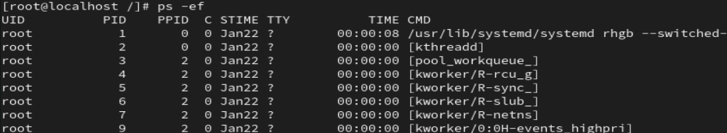
- Identify the PID of your current shell process.
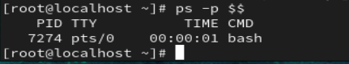
- Identify the PPID of a running process.
- Find a process started by the root user.
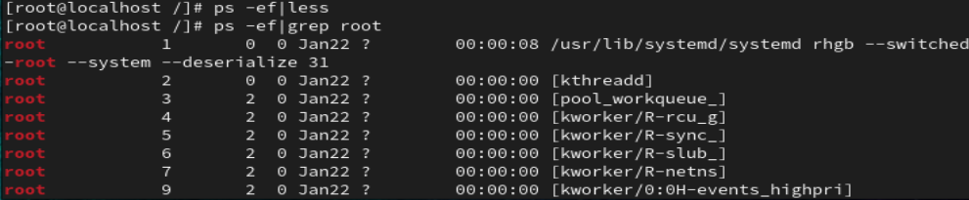
- Count the total number of running processes.
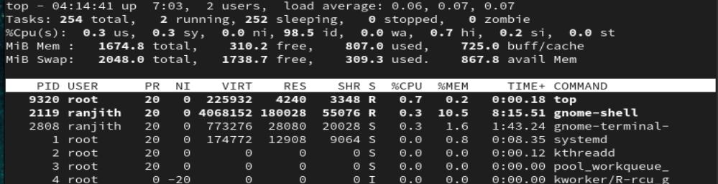
- Identify the command name of a process using its PID.
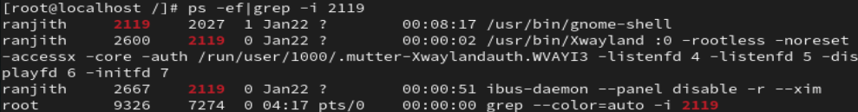
- Redirect the output of `ps -ef` to a file.

- Filter the process list for a specific user.
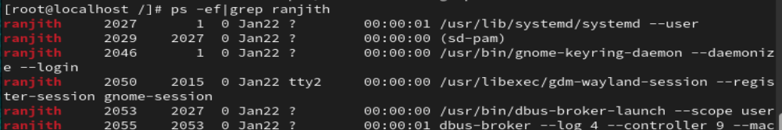
- Filter the process list for a specific PID.
- Verify whether a particular process is running.
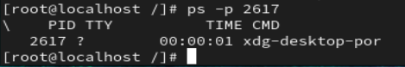

---

## 📊 Section 2: Process Monitoring with `top`

- Start the `top` command.
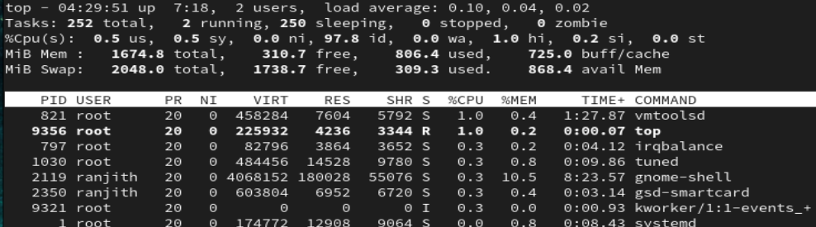
- Identify the PID column in the `top` output.
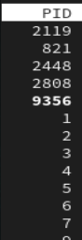

- Identify the USER field in `top`.
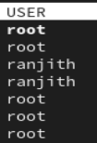
- Identify the `%CPU` field in `top`.
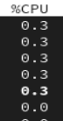
- Identify the `%MEM` field in `top`.
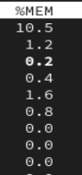
- Identify the `TIME+` field in `top`.
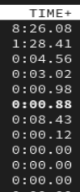
- Identify the `COMMAND` field in `top`.
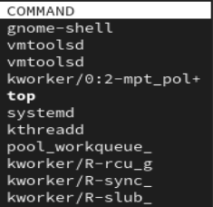
- Identify the process consuming the highest CPU.
- Identify the process consuming the highest memory.
- Exit safely from the `top` command.
Ctrl+c

---

## ⚙️ Section 3: CPU Load and Signals

- Run a `seq` command to generate numbers.
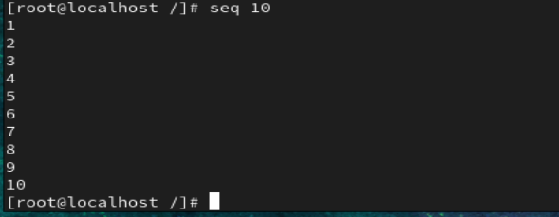
- Run `seq` in a way that consumes CPU continuously.
- Observe CPU usage of `seq` using `top`.
- Identify the PID of the running `seq` process.
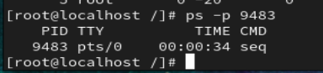
- Stop the `seq` process using signal 15.
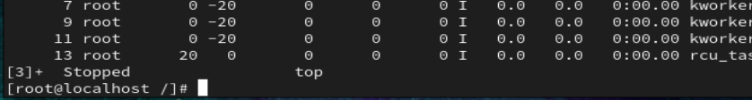

- Verify whether the process stopped gracefully.
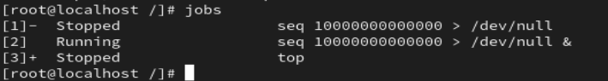
- Restart the `seq` process.
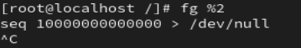
- Stop the process forcefully using signal 9.
- Pause a running process using signal 19.
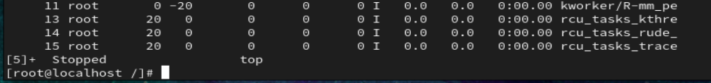
- Verify the process state after sending signal 19.

